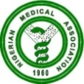 NIGERIAN MEDICAL ASSOCIATION 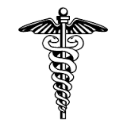
SECRETARIAT REPORT FOR THE MONTH OF MARCH, 2023
HIGHLIGHTS
The Secretariat activities for the month of March, 2023 are highlighted as follows:
WEEK 1  - The Secretary General had a meeting with the entire staff of the NMA Secretariat on staff welfare and other lingering issues.  WEEK 2  - The President Dr. Uche Ojinmah sent a release on the International women’s day to all NMA Platforms.  WEEK 3  - The President Dr. Uche Ojinmah led a delegation to commiserate with a staff of the NMA, Mr. Ogbaje Solomon on the demise of his wife.  - The President accompanied by Dr. Kefas Zawaya attended a second meeting of the Committee for the Operational Guideline of the National Health Insurance Act organized by the National Health Insurance Authority (NHIA) in Abuja.  - Notice/Invitation to the 2023 AGC/ADM Taraba 2023 was sent to Past Presidents, Past Secretaries’ General, Affiliate Heads, State Chairmen and Secretaries and Committee Chairmen.  - NMA Head of Admin, Mazi Emeka Akpa represented the Association at the World Consumer Rights Day 2023 and 91st Consumer Parliament of the Nigerian Communications Commission (NCC).  WEEK 4  - The President attended a Maternal, New Born and Child Health (MNCH) Summit 2023 organized by the Centre for Infectious Disease Research and Africa Center of Excellence for Population Health & Policy, Bayero University Kano in Abuja on the 21st March, 2023  - The President attended a stakeholders sensitization and expert group meeting on development of National Benchmark Statement and Minimum Standards for Training Care Givers/Agencies held in Abuja on the 22nd March, 2023.  - The Secretary General attended a Stakeholders Consultative/Briefing by the Special Independent Investigative Panel on Human Rights Violations in Counter-Insurgency Operations in North-East Nigeria held at the National Human Rights Commission, Abuja on 22nd March, 2023  - The President attended the NMA South South Zonal Executive Council meeting held at Calabar, Cross River State from the 24th to 26th March, 2023.  - NOC meeting held in Abuja on Monday 27th and Tuesday 28th March, 2023.  - Dr. George Nwadu represented the NMA at the NOTN Stimulation Program held on the 27th March, 2023.  - The President led a delegation to a courtesy visit to the Director General of the Nigeria Centre for Disease Control (NCDC) on 31st March 2023.  - A delegation from the Embassy of Russian Federation visited the NMA Secretariat for a meeting on 31st March 2923  - Members of Internal Audit Committee arrived Abuja on 31st March 2023 for the bi-annual audit session of the NMA Accounts.  REQUESTS  - Visit our website, www.nationalnma.org for the latest information and upcoming events of the Association.  - Send the names of Elected/Appointed Medical/Dental Practitioners in Executive/Legislative positions to the National Secretariat.  - Send pictures of activities of your State/FCT Branches and NMA Affiliate Groups to: drjideonyekwelu@yahoo.com and mekutivity2002@yahoo.co.uk  State executives are to send in the full names, office Address, State Secretariat Address, Email Address of the Chairman and Secretary to drjideonyekwelu@yahoo.com and copy mekutivity2002@yahoo.co.uk  This is to update our record.  ANNOUNCEMENT  AGC/ADM Taraba 2023 will be holding at the Catholic Event Centre Mile Six, Jalingo, Taraba State.  States are to bid for the hosting of the NMA statutory meetings. Physicians Week 2023, AGC/ADM 2024.  Signed:  Dr. Jide Onyekwelu  SECRETARY GENERAL | 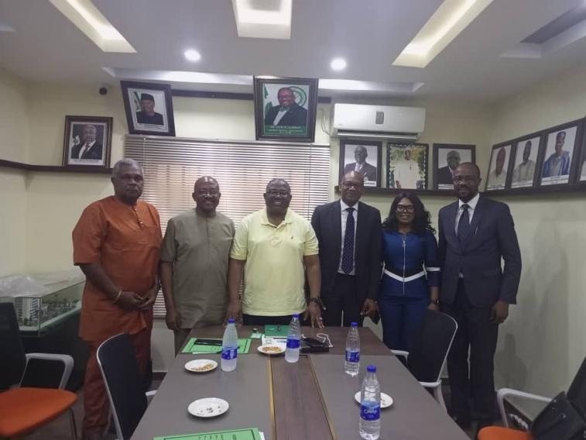  NMA delegation comprising of the President Dr. Uche Ojinmah, Secretary General Dr. Jide Onyekwelu and NMA National Committee Chairman, Dr. Akin Sodipo after a strategic meeting with Senior Management Staff of Stanbic IBTC Bank at the NMA National Secretariat Abuja. 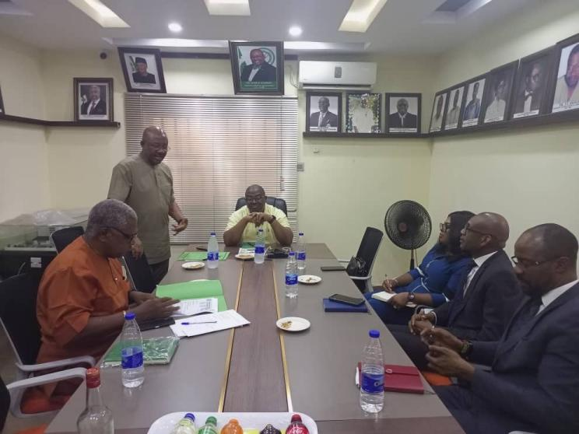  NMA Secretary General Dr. Jide Onyekwelu giving a remark during the meeting with Management staff of Stanbic IBTC Bank  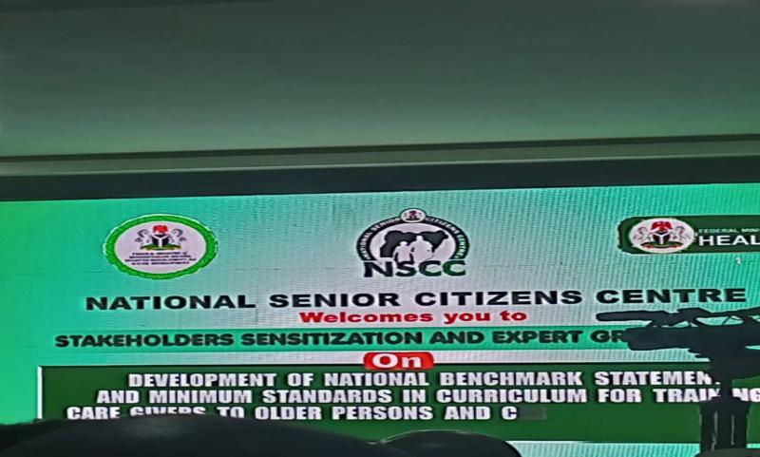  Stake holders meeting at National Senior Citizens Centre Abuja.  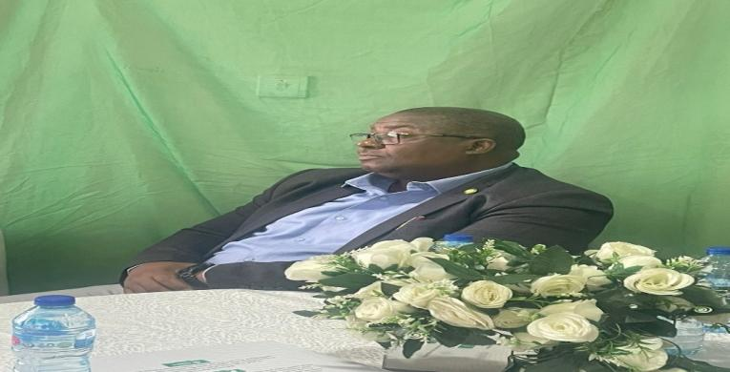  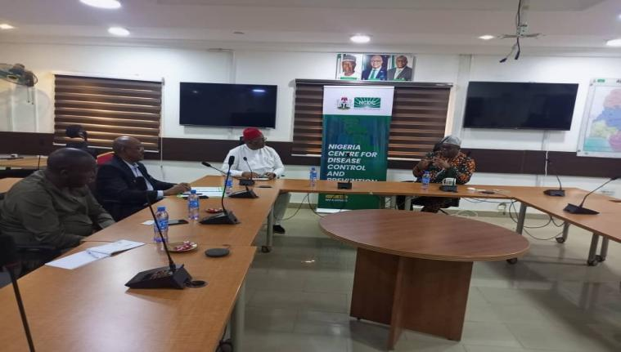  NMA President at the Stakeholders meeting at the National Senior Citizens Centre in Abuja  The President, Dr Uche Ojinmah, and his delegation, having a chat with the DG, NCDC  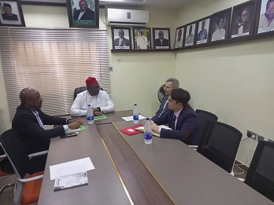  The President, Dr Uche Ojinmah and the Secretary General, Dr Jide Onyekwelu, discussing with the Russian delegation  T  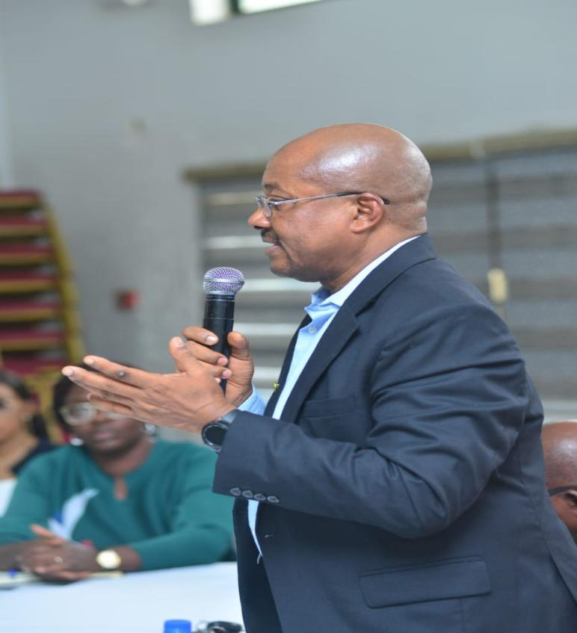  NMA Secretary General Making a deposition at the Stakeholders Meeting organized by the National Human Rights Commission in Abuja on Wednesday 22nd March, 2023  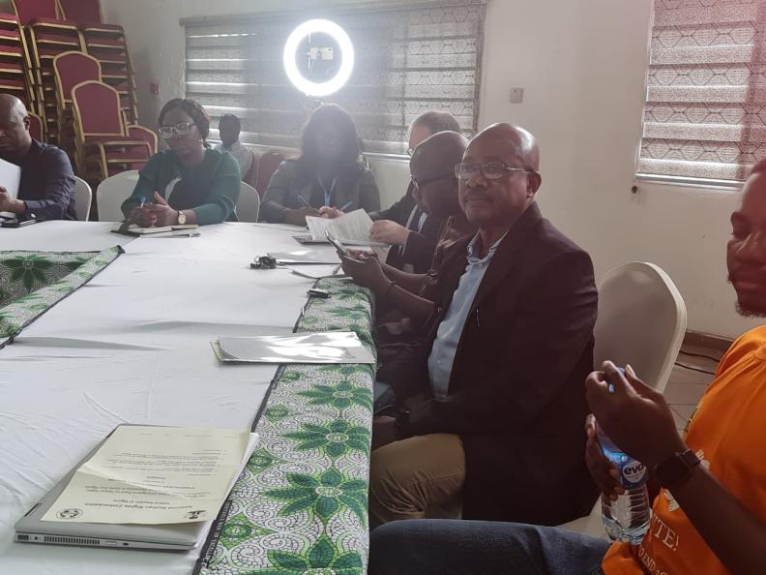  NMA Secretary General at the Stakeholders Meeting organized by the National Human Rights Commission in Abuja on Wednesday 22nd March, 2023  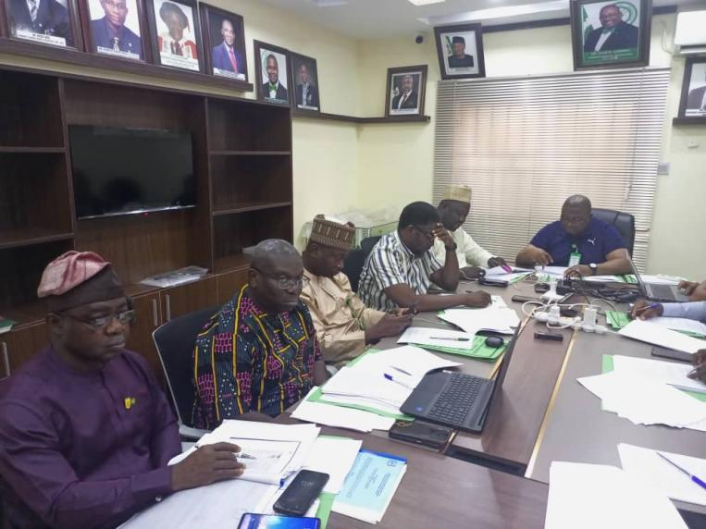  Cross section of NOC members during the March 2023 NOC meeting  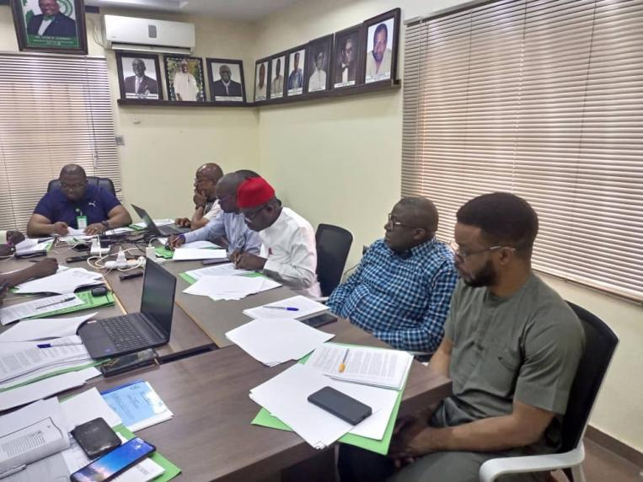  Cross section of NOC members during the March 2023 NOC meeting  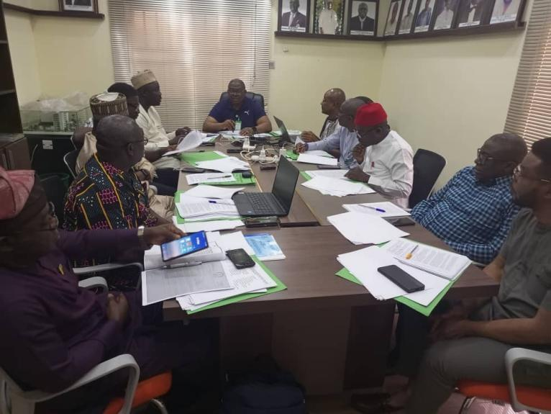  Cross section of NOC members during the March 2023 NOC meeting

