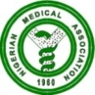 NIGERIAN MEDICAL ASSOCIATION 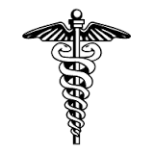
SECRETARIAT REPORT FOR THE MONTH OF FEBRUARY, 2023
HIGHLIGHTS
The Secretariat activities for the month of February, 2023 are highlighted as follows:
WEEK 1  - The President granted audience to a delegation from the Defense Headquarters, department of Defense Standards and Evaluation, at the NMA National Secretariat, Abuja.  - The President attended the First Ladies Against Cancer (FLAC) Initiative partner reception and Book Launch in Abuja.  - The Secretary General had a meeting with the entire staff of the NMA Secretariat on staff welfare and other lingering issues.  WEEK 2  - The President Dr. Uche Ojinmah granted audience to the Executive members of NiMSA at the NMA National Secretariat, Abuja.  - The President was Special Guest at the 2023 World Cancer Day Symposium organized by the Project Pink Blue at the Transcorp Hilton, Abuja  - The President accompanied by Dr. Kefas Zawaya attended the Committee meeting for the Operational Guideline of the National Health Insurance Act organized by the NHIA in Abuja.  WEEK 3  - External audit session took place at the NMA National Secretariat, Abuja.  - The President of Nigerian Medical Association Dr Uche R. Ojinmah paid a courtesy visit to the Vice Chancellor of University of Nigeria, Prof Charles A. Igwe. He was accompanied by NMA members within Enugu State to the visit.  - The NMA Constitution Review Committee met at the NMA Secretariat between the 16th and 18th of February, 2023  WEEK 4  - NMA President attended a stakeholders meeting organized by the National Health Insurance Authority at Chida Hotel, Abuja.  REQUESTS  - Visit our website, www.nationalnma.org for the latest information and upcoming events of the Association.  - Send pictures of activities of your State/FCT Branches and NMA Affiliate Groups to: drjideonyekwelu@yahoo.com and mekutivity2002@yahoo.co.uk  State executive is to send in the full names, office address, State secretariat address, email address of their Chairmen and Secretaries to drjideonyekwelu@yahoo.com and copy mekutivity2002@yahoo.co.uk  This is to update our record.  ANNOUNCEMENT  States are to bid for the hosting of the NMA statutory meetings. Physicians Week 2023, AGC/ADM 2024.  Signed:  Dr. Jide Onyekwelu  SECRETARY GENERAL | 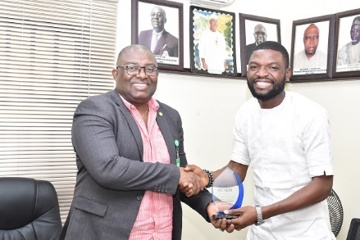  NiMSA President making a presentation to the NMA President during the visit of NiMSA leadership to the NMA Secretariat.  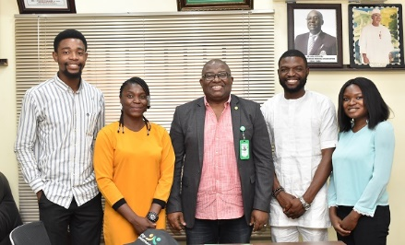  Cross section of NiMSA Leadership and the NMA President  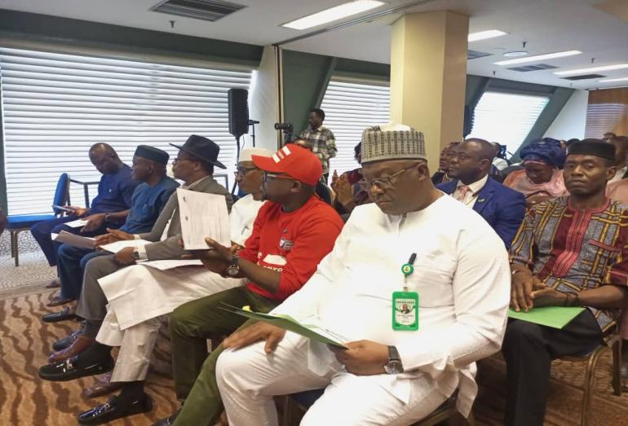  NMA President at the 2023 World Cancer Day symposium organized by Project Pink Blue at Transcorp Hilton Abuja.  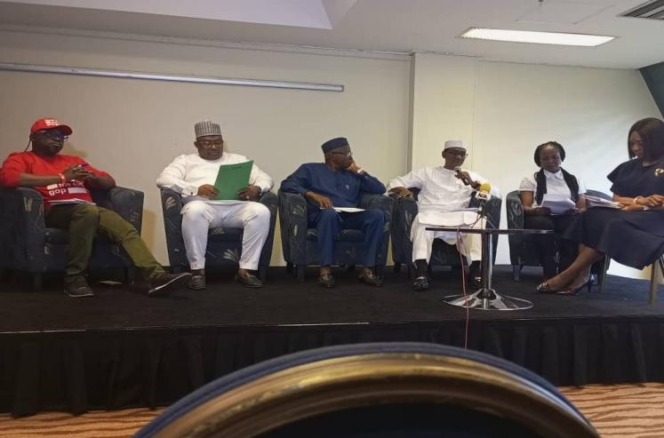  NMA President and other panelist at the World Cancer Day symposium at the Transcorp Hilton Abuja  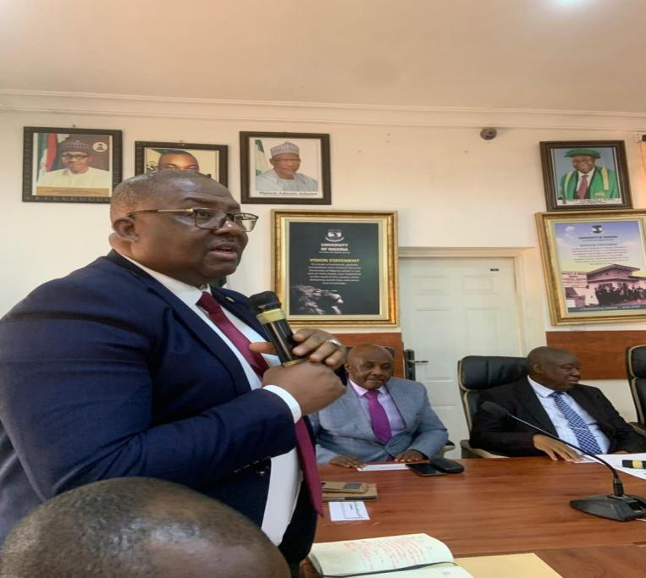  NMA President, Dr. Uche Ojinmah making a presentation during the courtesy visit to the Vice Chancellor of the University of Nigeria, Nsukka.  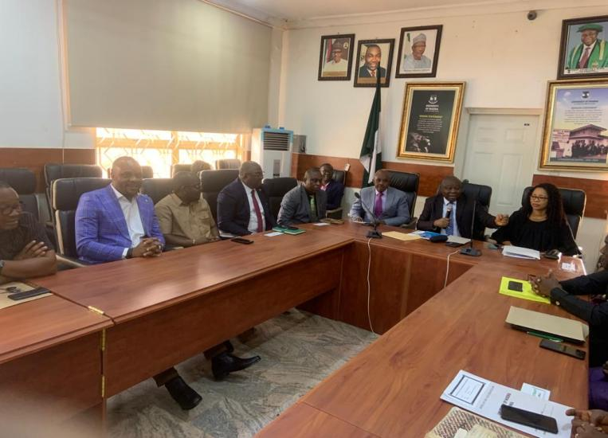Cross section of NMA and Management staff during the NMA President’s visit  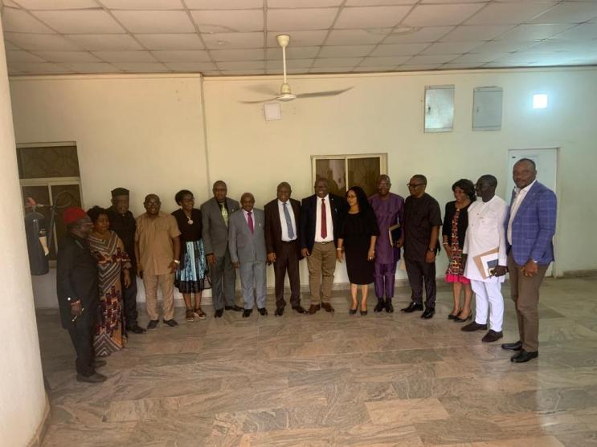  Cross section of NMA delegation led by the President and Management staff of the University of Nigeria Nsukka during the visit.

