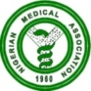 NIGERIAN MEDICAL ASSOCIATION 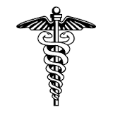
SECRETARIAT REPORT FOR THE MONTH OF SEPTEMBER, 2023
HIGHLIGHTS
Secretariat activities for the month of September, 2023 are highlighted as follows:
WEEK 1  - National Executive Council (NEC) meeting of the Nigerian Medical Association NMA was held from Sunday 27th August, 2023 to Sunday 3rd September, 2023.  - Below are parts of the events that spilled into first week of September 2023.  - Friday 1st of September, 2023 was NEC 1  - Saturday 2nd September, 2023 was NEC II  - Sunday 3rd September, 2023 was departure for all the NEC Members from Owerri, Imo State.  WEEK 2  - NMA President Dr. Uche Rowland Ojinmah attended the opening ceremony of the 23rd Biennial Conference and Scientific Meeting of the Medical Woman Association of Nigeria held from 12th to 16th of September, 2023 at Port-Harcourt, River State.  WEEK4  - NMA President Dr. Uche Rowland Ojinmah and Secretary General Dr. Jide Onyekwelu held a meeting with the leadership of the National Association of the Nigerian Nurses and Midwives at NANNM Conference Room Area 10 Garki, Abuja, 26th September, 2023.  - NMA President Dr, Uche Rowland Ojinmah attended the Opening Ceremony of the 43rd Annual General Meeting of the Nigerian Association of Resident Doctors (NARD) held on 28th September, 2023 at Peace Hall, Depeace Hotel, Ilorin Kwara State.  REQUESTS  - Visit our website, www.nationalnma.org for the latest information and upcoming events of the Association.  - Send pictures of activities of your State/FCT Branches and NMA Affiliate Groups to: drjideonyekwelu@yahoo.com and mekutivity2002@yahoo.co.uk  State executives are to send in the full names, office Address, State Secretariat Address, Email Address of the Chairman and Secretary to drjideonyekwelu@yahoo.com and copy mekutivity2002@yahoo.co.uk  This is to update our record.  ANNOUNCEMENT  December 2023 NEC Meeting will hold in FCT, Abuja from Sunday 10th December to Sunday 17th December, 2023 at WACS, Conference Center, Gaduwa, Abuja  States Chairmen, Committee Chairmen and Affiliate Bodies Should send in their report for December, 2023 NEC to  drjideonyekwelu@yahoo.com  mekutivity2002@yahoo.co.uk  States are to send a list of Medical Doctors in their States that were elected in the just concluded elections to the NMA National Secretariat.  Signed:  Dr. Jide Onyekwelu  SECRETARY GENERAL  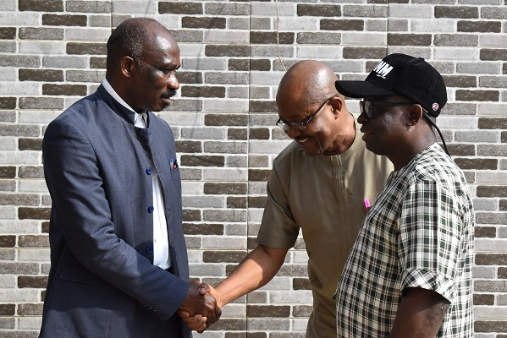  NMA Secretary General Dr. Jide Onyekwelu exchanging pleasantries with the NANNM President .  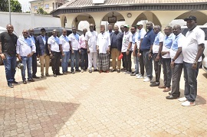  NMA President, Dr. Uche Rowland Ojinmah with his team in a group Photograph with Eze Barrister J. C. Okwara (Eshi of Nkwere).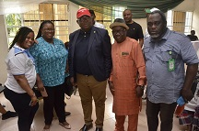  NMA President, Dr. Uche Rowland Ojinmah in a group photograph with the NMA National Secretariat Staff | 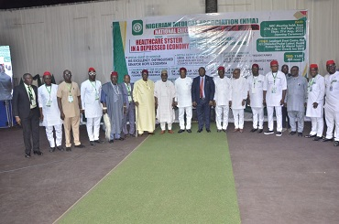  Group photograph of dignitaries with His Excellency, the Governor of Imo, NMA President and other NOC at NEC opening ceremony  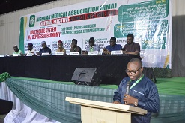  Dr. Innocent Egbeji Abang, Secretary Meeting Assessment Committee, making presentation on the Assessment of Jalingo NEC Meeting.  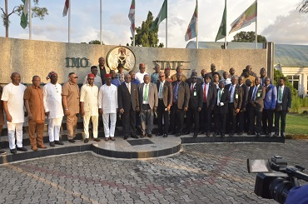  NMA President and the delegation in a group photograph during a courtesy visit to His Excellency, Hope Uzodinmah at Government House Owerri, Imo State.  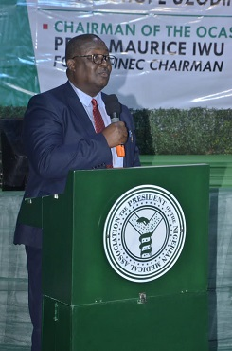  NMA President, Dr. Uche Rowland Ojinmah making his presentation during the opening ceremony of the NMA August NEC Meeting in Owerri, Imo State.  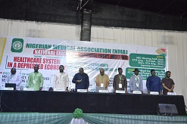  NMA National Officers’ Committee observing prayers during NEC II  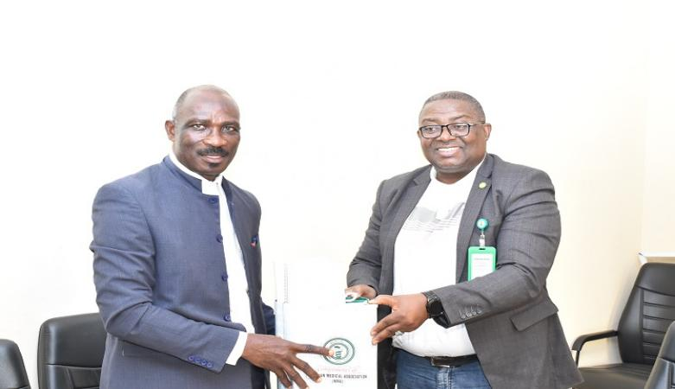  NMA President, Dr. Uche Rowland Ojinmah making presentation to NANNM President as a show of solidarity  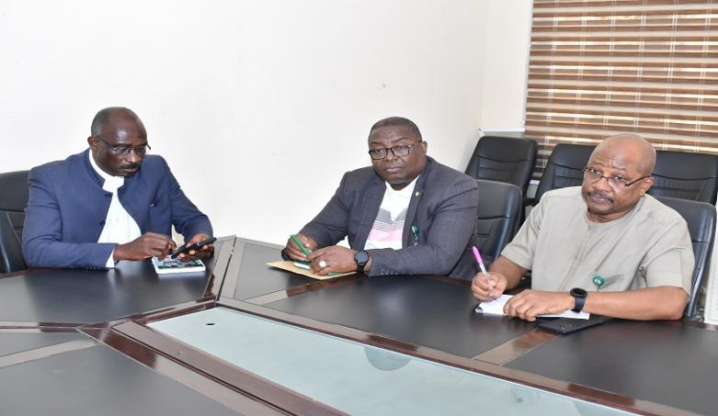  NANNM President making his remarks during the joint meeting held with the NMA at NANNM Conference room area 10 Garki, Abuja.  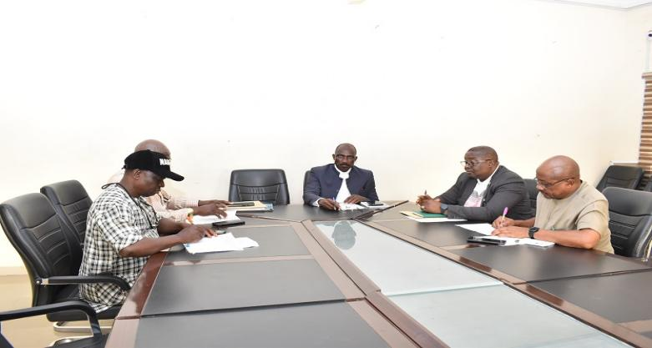  This is a session of the NMA Meeting with NANNM Executive .  s  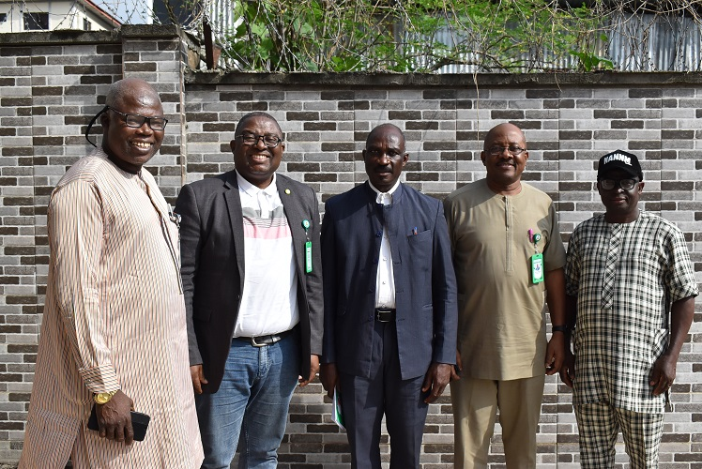  NMA President, Dr. Uche Rowland Ojinmah and the Secretary General Dr. Jide Onyekwelu in a group photograph with NANNM Executive during the NMA meeting with NANNM at NANNM Secretariat, Abuja.  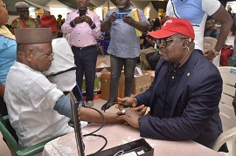  NMA President Dr. Uche Rowland Ojinmah checking the blood pressure of one of the first class chiefs in Owerri, Imo State

