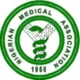 NIGERIAN MEDICAL ASSOCIATION 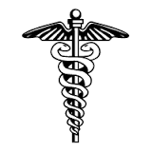
SECRETARIAT REPORT FOR THE MONTH OF APRIL. 2023
HIGHLIGHTS
The Secretariat activities for the month of April, 2023 are highlighted as follows:
WEEK 1  - The NMA Internal Audit Committee headed by the Chairman, Dr. Abdulgafar O. Jimoh, Secretary of the Committee, Dr. John Ohiri and Dr. Utcahy Agiri, member, performed their statutory functions of Auditing the NMA Account from 1st to 6th April, 2023.  WEEK 2  - Notification of the Outcome of the Emergency Extended National Officers’ Committee of the Nigerian Association of Resident Doctors held on Friday 7th April, 2023 was received at the NMA National Secretariat, Abuja.  - The First Vice President of the Nigerian Medical Association NMA, Dr. Sulaiman Usman Alhassan led a delegation to the National Assembly for a Public hearing on a Bill for an act to provide for the Establishment of Traditional Complementary and Alternative Medicine Council of Nigeria, and for related matters, on Thursday 13th April, 2023 at the Conference Room 236 New Wing, House of Representatives, Abuja.  WEEK 3  - The President, Dr. Uche Ojinmah, DGS Dr. Oyiguh Simeon, National Treasurer Dr. El-Yakub Yakubu and Editor Nigerian Medical Jourmal, Dr Datonye Alasia, attended the Council Session of the World Medical Association in Nairobi Kenya.  - Dr. Uche Philips Ekpe, Immediate Past Secretary General of the Nigerian Medical Association, represented the NMA President, Dr. Uche Rowland Ojinmah at a meeting for the Consideration of the Establishment of the Proposed Professional Assessment Academy of Nigeria, held on 13th of April, 2023 at JAMB Boardroom, Bwari, Abuja.  - Dr. Uche Philips Ekpe, Immediate past Secretary General, NMA represented the NMA President Dr. Uche Rowland Ojinmah at a one day Stakeholders Workshop on Occupational Accidents and Industrial Disasters: National Workplace Emergency Action Guide. This was held on the 18th April, 2023 at Reiz Continental Hotel, Abuja.  - Notice/Invitation to the Nigerian Medical Association Annual General Conference/Delegate Meeting was sent to the relevant Ministries, Agencies, some Health related and none related Stakeholders, all past Presidents, Past Secretaries General, State Chairmen and Secretaries, Regulatory and Affiliate Bodies and all the Committee Chairmen.  WEEK 4  - NMA President, Dr. Uche Rowland Ojinmah on the 25th of April, 2023 held a Crucial Meeting with the Honourable Minister of Labour and Employment, Senator Dr. Chris N. Ngige at the Honourable Minister’s office, Abuja.  - NMA President, Dr. Uche Rowland Ojinmah on the 26th of April, 2023 had a crucial meeting with all the Nigerian Medical Association Affiliate Heads at the NMA Conference Room, Abuja.  - A letter on the Upward Review of CONMESS from the Nigerian Medical Association was sent to the Honourable Minister of Labour and Employment, Senator Dr. Chris N. Ngige on the 26th of April, 2023  - NMA President, Dr. Uche Rowland Ojinmah attended a Pre –Birthday Symposium Titled ‘’Living a life of Purpose and Impact’’, at the 60th Birthday of Dr. Obiageli Ezekwesili held on 27th April, 2023 at Merit House, Maitama, Abuja.  - Dr. Israel Jeremiah, the National Publicity Secretary of the NMA represented the NMA President Dr. Uche Rowland Ojinmah at the 45th AGC/International Scientific Conference of the Association of Nigerian Private Medical Practitioners held on 27th April, 2023 in Warri, Delta State.  - The Chairman NMA FCT, Dr. Charles Ugwuanyi, represented the NMA President, Dr. Uche Rowland Ojinmah at the 13th ANAN President Investiture Ceremony held on the 29th of April, 2023 at the AGNL Event and entertainment Complex, Abuja.  - Members of the National Officers Committee, Specific Committee Chairmen and Secretariat Staff arrived Jalingo, Taraba State for the AGC/ADM on 30th April, 2023.  REQUESTS  - Visit our website, www.nationalnma.org for the latest information and upcoming events of the Association.  - Send pictures of activities of your State/FCT Branches and NMA Affiliate Groups to: drjideonyekwelu@yahoo.com and mekutivity2002@yahoo.co.uk  State executives are to send in the full names, office Address, State Secretariat Address, Email Address of the Chairman and Secretary to drjideonyekwelu@yahoo.com and copy mekutivity2002@yahoo.co.uk  This is to update our record. | 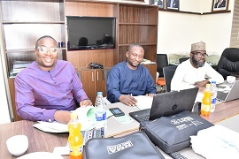  Audit session of the Internal Audit Committee at the NMA National Secretariat Conference Room, Abuja.  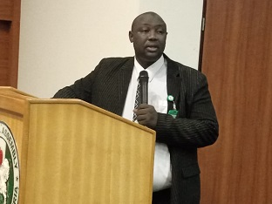  NMA 1st Vice President, Dr Sulaiman U. Alhassan making presentation during a public hearing at the National Assembly, Abuja.  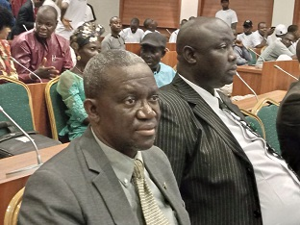  NMA 1st Vice President Dr. Sulaiman Alhassan and Dr. Omakoji Simeon Oyiguh, the DSG, at National Assembly during Public hearing.  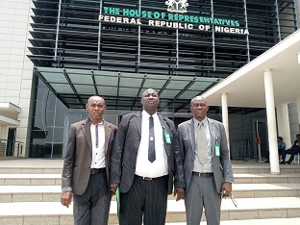  NMA 1ST Vice President, Dr. Sulaiman Alhassan, Dr. Omakoji Simeon Oyiguh, DSG, and Mazi Akpa Emeka, Head of Administration after NMA Presentation in National Assembly, Abuja.  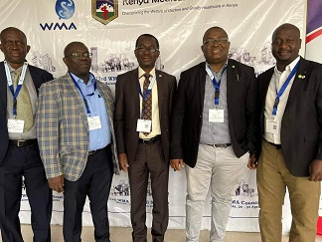  Nigerian Delegates with WMA President at WMA Council Session in Nairobi, Kenya  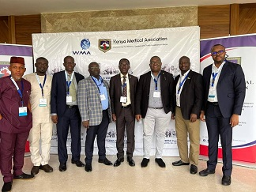  NMA President, Dr. Uche Ojinmah with WMA President Dr. Osahon Enabulele and other delegates from Nigeria in a group picture during WMA Council Session Hosted by Kenyan Medical Association.  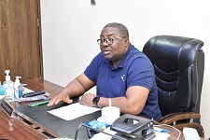  NMA President, Dr. Uche Ojinmah, responding to the questions from the Editorial Crew of NMA MediNews.  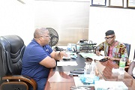  Administrative Editor of the NMA Medinews Mazi Emeka Akpa interviewing the NMA President , Dr. Uche R. Ojinmah in preparation for the NMA Medi-News 2nd Quarter 2023 Edition.  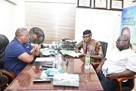  NMA President, Dr. Uche R. Ojinmah with some Editorial Assistants of NMA MediNews.  ANNOUNCEMENT  States are to bid for the hosting of the NMA statutory meetings. Physicians Week 2023, AGC/ADM 2024.  Signed:  Dr. Jide Onyekwelu  SECRETARY GENERAL

