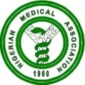 NIGERIAN MEDICAL ASSOCIATION 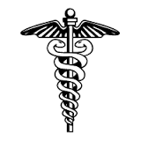
SECRETARIAT REPORT FOR THE MONTH OF JUNE, 2023
HIGHLIGHTS
The Secretariat activities for the month of June, 2023 are highlighted as follows:
WEEK 1  - NMA President, Dr. Uche Rowland Ojinmah led delegation on a visit to Congratulate Dr. ( Mrs) Salma Anas Kolo on her Appointment as the Director of Hospital Services, Federal Ministry of Health.  - the Secretary General of the Nigerian Medical Association, Dr. Jide Onyekwelu, on the 2nd of June, 2023 held a meeting with all the NMA Secretariat Staff, at the Conference room of the NMA National Secretariat, Abuja.  - NMA President, Dr. Uche Rowland Ojinmah attended the first Induction and Oath Taking Ceremony of the Medicine and Surgery Graduands of Edo State University, Uzairue, Edo State on 5th June, 2023.  - Letter on the Adjustment of Consolidated Health Salary Structure (CONHESS): Matters Arising was sent to the Permanent Secretary Federal Ministry of Health, and copied other relevant Ministries, Agencies and Parastatals of Government.  - NMA President, Dr. Uche Roland Ojinmah and Dr. Philips Uche Ekpe, attended the Association of Nigerian Physicians in the America (ANPA) Annual Convention held in the Month of July, 2023 in America  WEEK 2  - The NMA President , Dr. Uche Roland Ojinmah played host to the President Nigeria Internet Registration Association (NIRA) Mr. Adesola Akinsanya and his top management team at the NMA National Secretariat, Abuja on 15th of June, 2023. to formally introduce NIRA, know the Module-Oparandi of NIRA and see how both can partner.  WEEK 3  - Mr. Emeka Akpa the Head of Admin of NMA attended the NCC 2ND Quarter 2023 open Forum of the Industry Consumer Advisory Forum (ICAF) held on Thursday 22nd June, 2023 at Radisson Blu Hotel, Ikeja, Lagos.  REQUESTS  - Visit our website, www.nationalnma.org for the latest information and upcoming events of the Association.  - Send pictures of activities of your State/FCT Branches and NMA Affiliate Groups to: drjideonyekwelu@yahoo.com and mekutivity2002@yahoo.co.uk  State executives are to send in the full names, office Address, State Secretariat Address, Email Address of the Chairman and Secretary to drjideonyekwelu@yahoo.com and copy mekutivity2002@yahoo.co.uk  This is to update our record.  ANNOUNCEMENT  August 2023 NEC Meeting will hold in Owerri, Imo State from Sunday 27th August to Sunday 3rd September, 2023 at Land Mark Event Centre, Owerri.  States Chairmen, Committee Chairmen and Affiliate Bodies Should send in their report for August NEC to  drjideonyekwelu@yahoo.com  mekutivity2002@yahoo.co.uk  Signed:  Dr. Jide Onyekwelu  SECRETARY GENERAL | 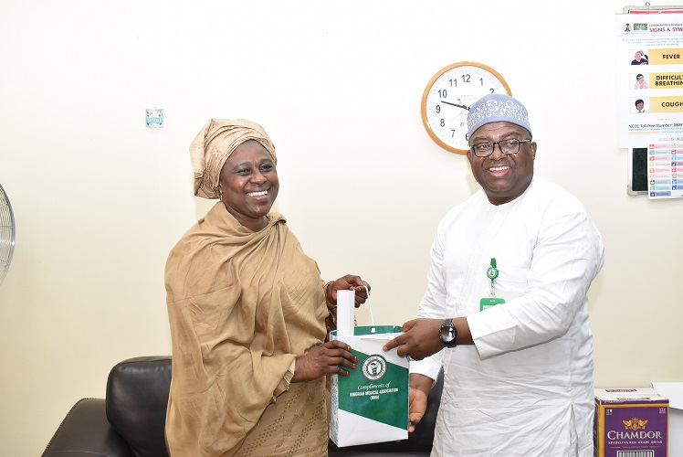  NMA President, Dr. Uche Rowland Ojinmah making presentation to the Director of Hospital Services, Dr. (Mrs.) Salma Kolo during the NMA Courtesy Visit to her Office.  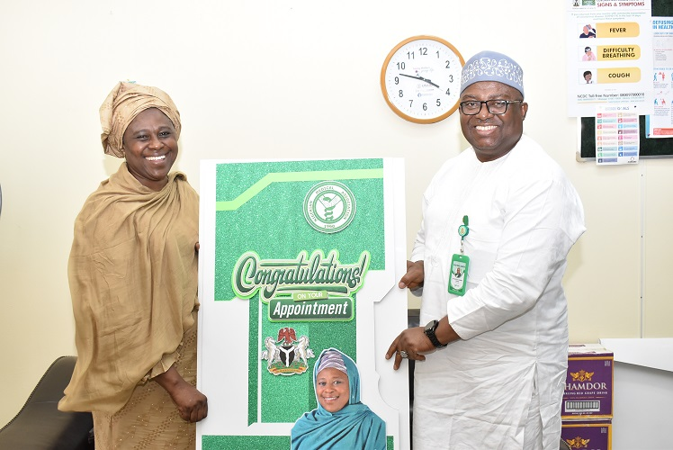  NMA President, Dr. Uche Rowland Ojinmah presenting a Congratulatory Card to Dr. Mrs Salma Kolo on her new appointment as the Director of Hospital Services (DHS)  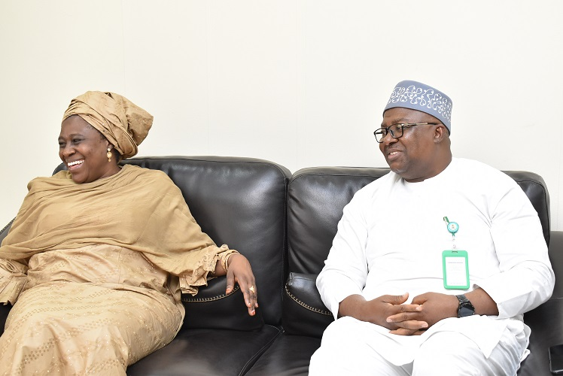  NMA President, Dr. Uche Rowland Ojinmah Seated discussing Issue on Health with Dr. Mrs. Kolo  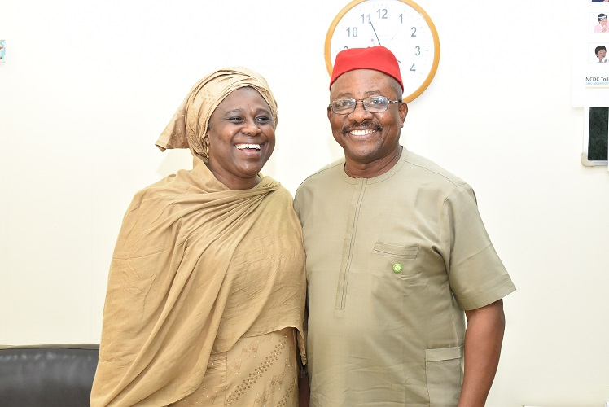  NMA Secretary General Dr. Jide Onyekwelu in a picture with Dr. Mrs Salma Kolo Director of Hospital Services, (FMOH)  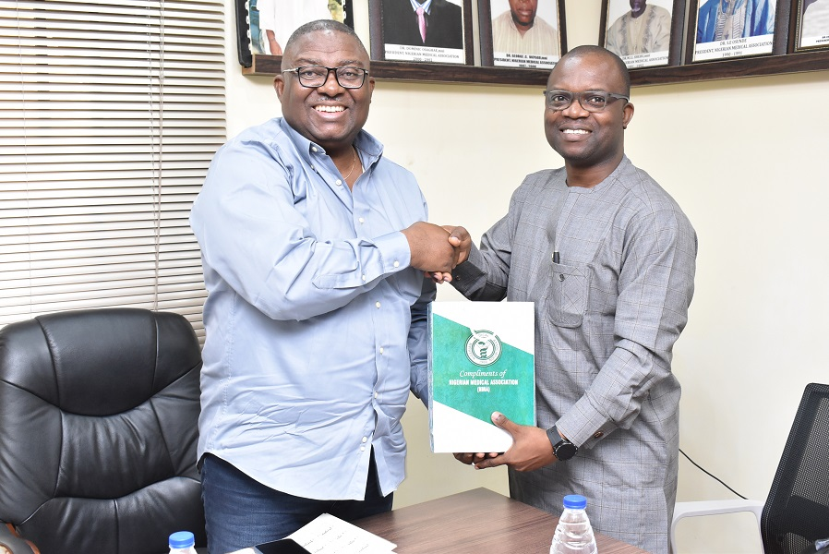  NMA President Dr. Uche Rowland Ojinmah making presentation to the President , Nigeria Internet Registration Association Mr. Adesola Akinsanya on their visit to the NMA National Secretariat, Abuja.  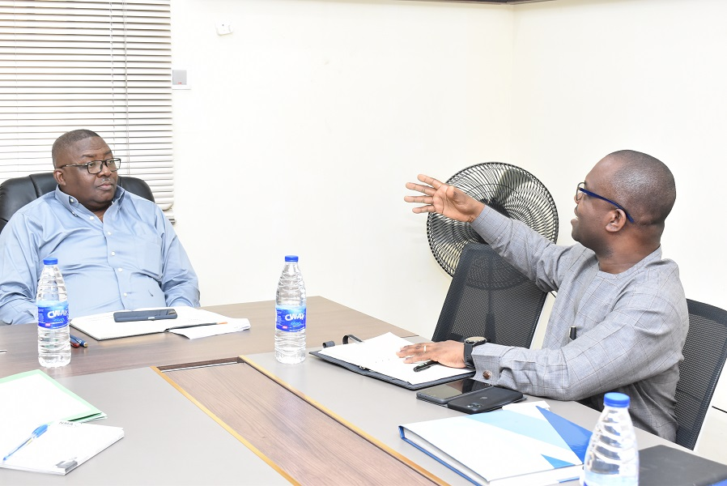  NMA President, Dr. Uche Rowland Ojinmah seated, listening to the Presentation, by the President NIRA Mr. Adesola Akinsanya.  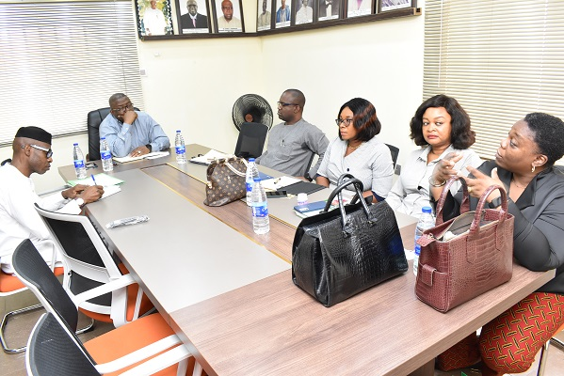  Nigeria Internet Registration Association (NIRA) Executives having a meeting session with the NMA President.

