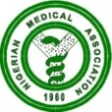 NIGERIAN MEDICAL ASSOCIATION 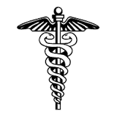
SECRETARIAT REPORT FOR THE MONTH OF JULY, 2023
HIGHLIGHTS
The Secretariat activities for the month of July, 2023 are highlighted as follows:
WEEK 1  - Dr. Henry Emeka Ikeabbah Chairman NMA Committee on Malaria and T.B represented the NMA President, Dr. Uche Rowland Ojinmah at the Annual National Severe Malaria Stakeholders Meeting held on 5th and 6th July, 2023 at Raiz Continental Hotel, Central Business District, Abuja.  WEEK 2  - Dr. Job Enema Amodu, Chairman, NMA Committee on Clinical Governance represented the NMA President, Dr. Uche Rowland Ojinmah at the Nigerian Bar Association, Abuja branch (Unity Bar) 2023 Law week held on Thursday 13th July, 2023 at the Saphire Hall of A-Class Event Center, Wuse II, Abuja.  WEEK 3  - National Officers’ Committee (NOC) Meeting of the Nigerian Medical Association held on Monday 17th July, 2023 and Tuesday 18th July, 2023 at the NMA National Secretariat Conference Room, Abuja.  - NMA President, Dr. Uche Rowland Ojinmah led other National Officers on a courtesy visit to Honourable (Dr) Yusuf Tanko Sununu to Congratulate him on his victory at the poll following his election as Hon. Member House of Representative.  - NMA President, Dr. Uche Rowland Ojinmah led delegation to a conciliation meeting between the NMA and NARD at the instance of Federal Ministry of Health and other relevant Government Agencies. This was held on 17th July, 2023 at the Honourable Minister’s Conference Room, Abuja.  WEEK 4  - Dr. Philips Uche Ekpe represented the NMA President, Dr. Uche Roland Ojinmah at an emergency meeting held by the leadership of the House of Representatives with other critical stakeholders on the health sector to look at the pending issues on the NARD proposed strike and other burning issues causing disharmony in the health sector. This meeting was held on Thursday 27th July, 2023 at room 418 Conference room, National Assembly Complex, Abuja.  - Dr. Nsikak Nyoyoko represented the NMA President at the Funeral Service of late Dr. (Mrs) Patience Nkem Nosa at their Compound Ekaya Okobo Local Government Area of Akwa-Ibom State.  REQUESTS  - Visit our website, www.nationalnma.org for the latest information and upcoming events of the Association.  - Send pictures of activities of your State/FCT Branches and NMA Affiliate Groups to: drjideonyekwelu@yahoo.com and mekutivity2002@yahoo.co.uk  State executives are to send in the full names, office Address, State Secretariat Address, Email Address of the Chairman and Secretary to drjideonyekwelu@yahoo.com and copy mekutivity2002@yahoo.co.uk  This is to update our record.  ANNOUNCEMENT  AGC/ADM Taraba 2023 was held at the Catholic Event Centre Mile Six, Jalingo, Taraba State.  August 2023 NEC meeting will hold in Owerri, Imo State from Sunday 27th August to Sunday 3rd September, 2023 at Land Mark Event Centre, Owerri.  States Chairmen, Committee Chairmen and Affiliate Bodies Should send in their reports for August NEC to  drjideonyekwelu@yahoo.com  mekutivity2002@yahoo.co.uk  States are to send a list of Medical Doctors in their States that were elected in the just concluded elections to the NMA National Secretariat.  Signed:  Dr. Jide Onyekwelu  SECRETARY GENERAL  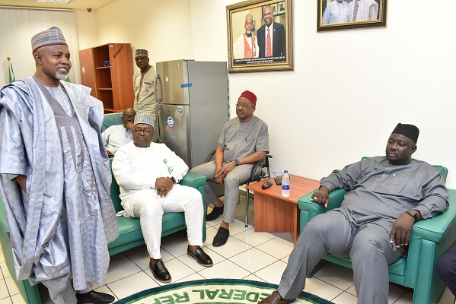  Hon. Dr. Yusuf Tanko Sununu responding to a speech delivered by the NMA President, Dr. Uche Rolwland Ojinmah.  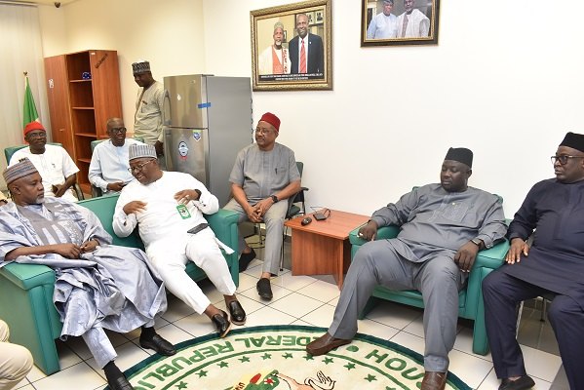  NMA President, Dr. Uche Rowland Ojinmah commenting on some vital points raised during the discussion session. .  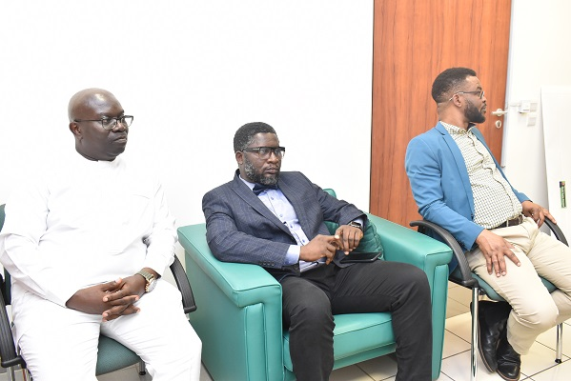  Cross Section of the NMA delegation that visited Hon. Dr. Yusuf Tanko Sununu  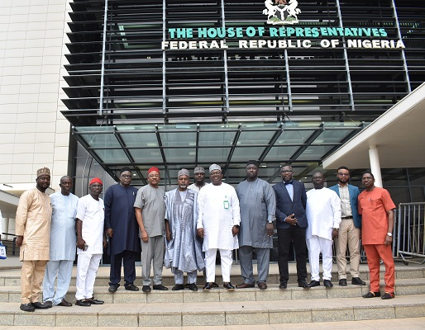  NMA Delegation in a group picture with Honourable Dr. Yusuf Tanko Sununu at the National Assembly Complex, Abuja. | 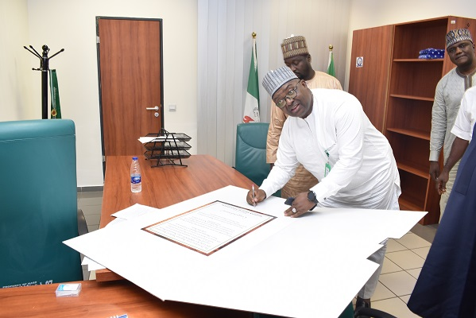  NMA President, Dr. Uche Rowland Ojinmah appending his signature on a congratulatory card for Hon. Dr. Yusuf Tanko Sununu.  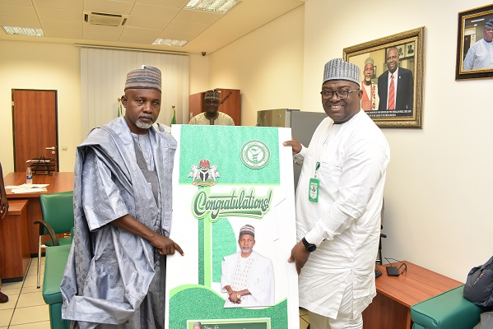  NMA President, Dr. Uche R. Ojinmah, presenting a congratulatory card to Hon. Dr. Yusuf Tanko Sununu during a courtesy visit to him to congratulate him on his re-election.  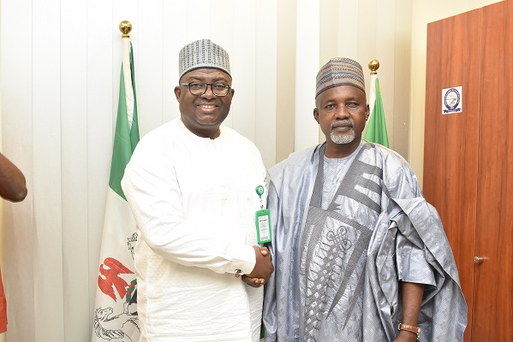  NMA President. Dr. Uche Rowland Ojinmah having a hand shake with Hon. Dr. Yusuf Tanko Sununu.  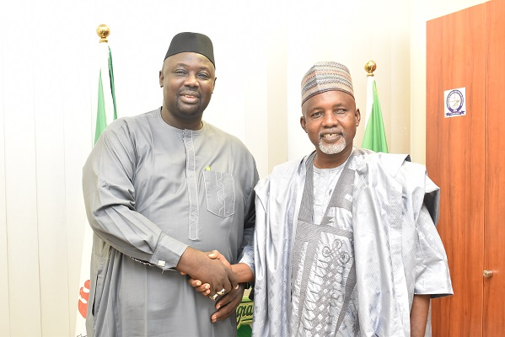  NMA 1st Vice President , Dr. Sulaiman Alhassan having a hand shake with Hon. Dr. Yusuf Tanko Sununu  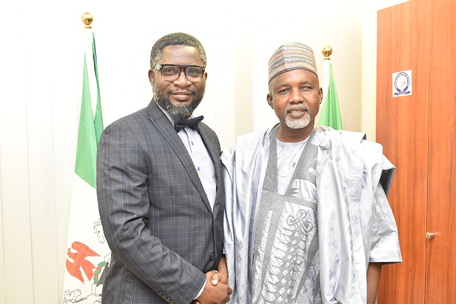  NMA 2nd Vice President, Dr. Adetunji O. Adenekan exchanging pleasantries with Hon. Dr. Yusuf Tanko Sununu.  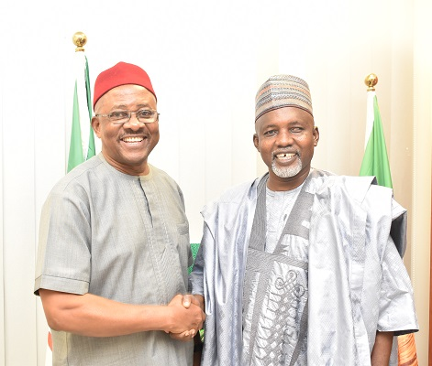  NMA Secretary General, Dr. Jide Onyekwelu exchanging pleasantries with Hon. Dr. Yusuf Tanko Sununu during the NMA courtesy visit to his office  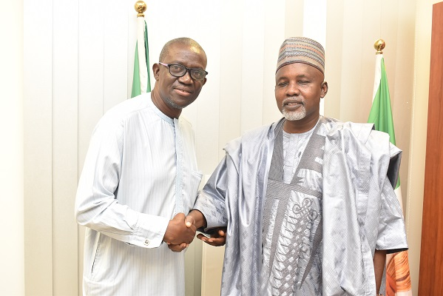  NMA Deputy Secretary General, Dr. Omakoji Simeon Oyiguh having a hand shake with Hon. Dr. Yusuf Tanko Sununu 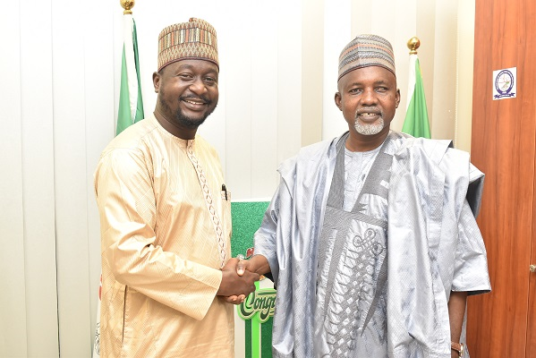  NMA National Treasurer, Dr. Yakub M. El-Yakub exchanging pleasantries with Hon. Dr. Yusuf Tanko Sununu  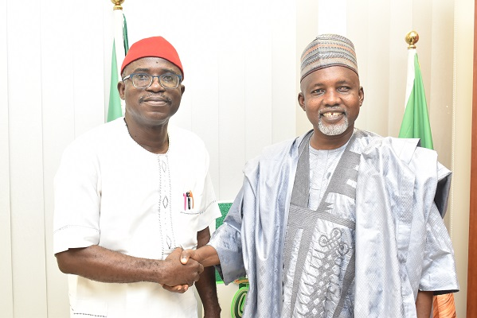  Dr. Dolani Z. Gbelela, NMA National Financial Secretary having a hand shake with Hon. Dr. Yusuf Tanko Sununu  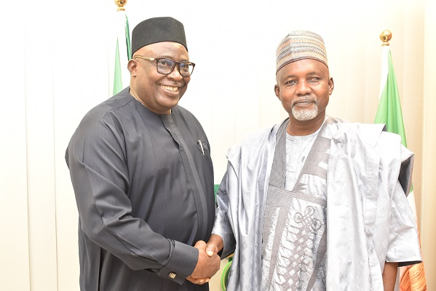  Dr. Jeremiah Israel, NMA National Publicity Secretary exchanging pleasantries with Hon. Dr. Yusuf Tanko Sununu  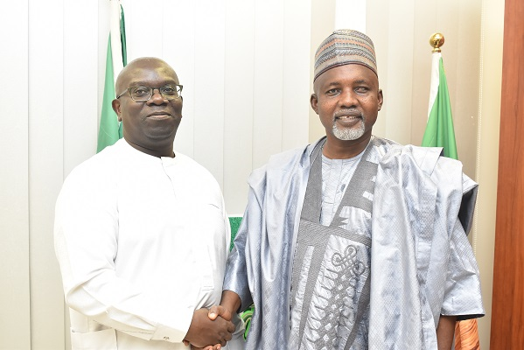  NMJ Editor, Dr. Datonye Alasia having a hand shake with Hon. Dr. Yusuf Tanko Sununu  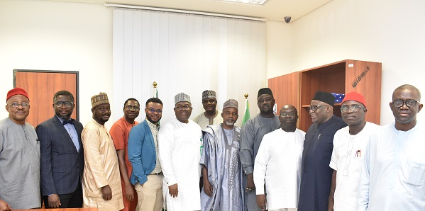  A group Photograph of NMA delegation with Hon. Dr. Yusuf Tanko Sununu, during the NMA visit to his office.  