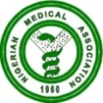 NIGERIAN MEDICAL ASSOCIATION 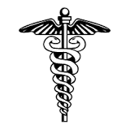
SECRETARIAT REPORT FOR THE MONTH OF MAY 2023
HIGHLIGHTS
The Secretariat activities for the month of May, 2023 are highlighted as follows:
WEEK 1  - The Nigerian Medical Association’s 63rd Annual General Conference (AGC)/Annual Delegates Meeting (ADM) held from 30th April, 2023 to 7th May, 2023 at the Catholic Event Centre, Jalingo, Taraba State.  - Activities of the 63rd Annual General Conference /Annual Delegates Meeting.  - On Sunday 30th April, 2023 was the arrival of the National Officers’ Committee (NOC) and the Secretariat Staff.  - Monday 1st May, 2023 was the flag off of Dr. Ameyo Stella Adadevoh Medical outreach at the First Referral Hospital, Mutum Biyu, Gassol LGA after which the NMA delegation visited the factory complex of NATU Water PLC  - On Tuesday 2nd May, 2023 was a courtesy visit to the Vice Chancellor, Taraba State University, Prof. Sunday Paul Bako, Hon. Commissioner for Health, Honourable Dr. Innocent Vakkai, and the Medical Director Federal Medical Centre, Jalingo Taraba State, Dr. Aisha Shehu Adamu.  - Tuesday 2nd May, 2023 was arrival of Delegates from 36 States and the FCT, Abuja. There was a welcome cocktail for the delegates.  - On Wednesday 3rd of May, 2023 were CME, Presentations and Opening Ceremony for the 63rd AGC/ADM which held at Catholic Event Center, Jalingo, Taraba State  - On Thursday 4th May, 2023 there were presentations from the Exhibitors and NEC I.  - NEC II and plenary held on Friday 5th May 2023  - On Saturday 6th May, 2023 was an Annual Delegates meeting followed immediately by a Press Conference and then a Closing Dinner that marked the end of the 63rd Annual General Conference/Delegate meeting of the Nigerian Medical Association which held from 30th April, 2023 to 7th May, 2023 at Catholic Event Centre, Jalingo, Taraba State.  - Sunday 7th May, 2023 was departure of all the delegates from Jalingo.  WEEK 2  - NMA President Dr. Uche Rowland Ojinmah was Conferred with the Award of the Prestigious Fellow of the National Institute (fni) by Michael Imoudu National Institute for Labour Studies.  This held on the 9th of May, 2023 at the Institute’s Headquarters in Iloirin, Kwara State.  - A letter was sent to the Executive Governor of Anambra State Prof. Charles C. Soludo on the appointment of a non-medical Doctor as Executive Secretary of the Anambra State Primary Health Care Development Board. This was sent on the 10th of May, 2023 and received on the 12th of May 2023.  - The NMA President Dr. Uche Rowland Ojinmah on the 12th of May, 2023 had a press engagement with Channels Global Television Network Africa (CGTN).  - NMA President, Dr. Uche Rowland Ojinmah led a delegation to the Burial of the NMA Elder Statesman Past President, DR. EDMUNSON THOMPSON AKPABIO who passed on to glory on Tuesday 7th March, 2023. The Burial ceremony took place on the 13th May, 2023 at his Home town Mkpok Onna, Akwa-Ibom State.  WEEK 3  - NMA National Publicity Secretary, Dr. Jeremiah Israel represented the NMA President Dr. Uche Rowland Ojinmah at the Burial Ceremony of Emeritus Professor Nimi Dimkpa Briggs who passed away on the 10th of April, 2023. The Ceremony took place on 16th April, 2023 at UPTH.  - NMA Secretary General Dr. Jide Onyekwelu represented the NMA President, Dr. Uche Rowland Ojinmah at the Burial Ceremony of Dr. M. C. Nnoba which took place on the 19th of May, 2023 at Onitsha, Anambra State.  - NMA Secretary General, Dr Jide Onyekwelu, represented The President, Dr Uche Ojinmah at the burial of Prince Michael Ekumankama, the late father of Hon Minister of State for Health, Barr Joseph Ekumankama on 13th May, 2023. In the delegation were Dr Dubem Awachie, National Committee Chairman on Doctors Statistics, Dr McSteve Okeke, Chairman NMA Ebonyi State and Dr Celestine Ugwuoke, Chairman NMA Enugu State  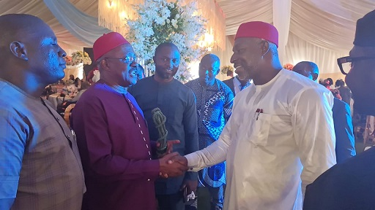  The Secretary General, Dr Jide Onyekwelu, exchanging pleasantries with the Minister of State for Health, Barr Ekumankama, during the burial of his father.  WEEK 4  - Dr. Uche Philips Ekpe Immediate Past Secretary General of the NMA represented the NMA President Dr. Uche Rowland Ojinmah at a one day Advocacy meeting with Professional Stakeholders on the introduction of the Human Papiloma Virus Vaccine held on 31st of May, 2023 at NAF Conference Centre, Abuja.  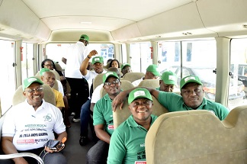  NMA Secretary General, Dr. Jide Onyekwelu leading a Contingent for a Medical mission in Mutum Biyu Jalingo, Taraba State.  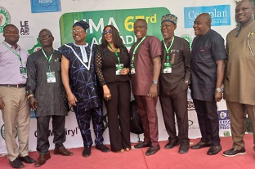  NMA Anambra Contingent at the 63rd NMA Annual General Conference/Annual Delegates Meeting in Jalingo, Taraba State.  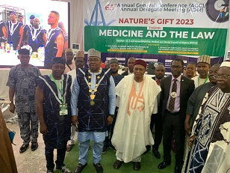  Group Photograph of the NMA President, Taraba State Governor, WMA President and others during the Opening Ceremony of the 63rd NMA AGM/ADM.  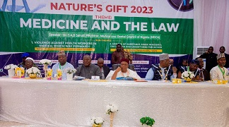  Group Photograph of the Dignitaries on the High Table during the Opening Ceremony of the 63rd NMA AGC/ADM in Taraba, State  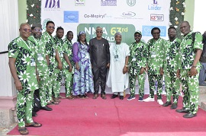  NMA FCT Contingent during the 63rd NMA AGC/ADM in Jalingo, Taraba State.  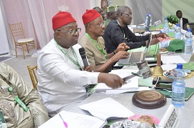  NMA President, Dr. Uche Rowland Ojinmah presiding over the NEC Meeting  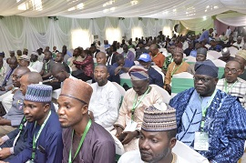  Cross section of delegates at the opening ceremony of the AGC/ADM  REQUESTS  - Visit our website, www.nationalnma.org for the latest information and upcoming events of the Association.  - Send pictures of activities of your State/FCT Branches and NMA Affiliate Groups to: drjideonyekwelu@yahoo.com and mekutivity2002@yahoo.co.uk  State executives are to send in the full names, office Address, State Secretariat Address, Email Address of the Chairman and Secretary to drjideonyekwelu@yahoo.com and copy mekutivity2002@yahoo.co.uk  This is to update our record. | 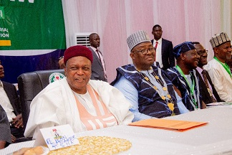  Photograph of the dignitaries on the high table during the opening ceremony of the 63rd AGC/ADM of the NMA in Jalingo, Taraba State  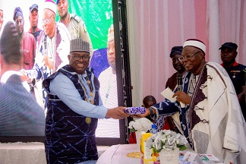  NMA President, Dr Uche Rowland Ojinmah receiving a gift item from the first class Traditional ruler in Jalingo, Taraba State during the opening ceremony of the NMA AGC/ADM.  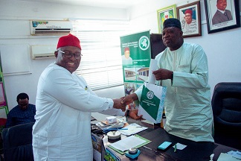  NMA President Dr. Uche Rowland Ojinmah making a presentation to the Hon. Commissioner for health, Taraba State Dr. Innocent Vakkai during a visit by NMA delegation to his office.  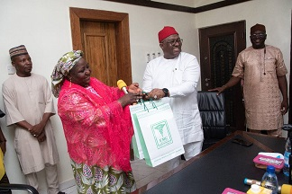  NMA President Dr. Uche Rowland Ojinmah making a presentation to the CMD, FMC Taraba State Dr. Aisha Adamu  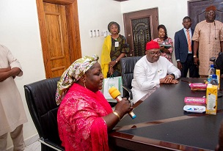  CMD, FMC Taraba State Dr. Aisha Shehu Adamu making her remarks during a visit by NMA delegation led by the NMA President, Dr. U. R. Ojinmah to her office.  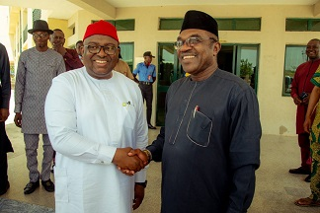  NMA President Dr. Uche Rowland Ojinmah exchanging pleasantries with the Vice Chancellor Taraba State University, Prof. Sunday Paul Bako during NMA Visit to the University  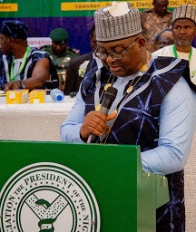  NMA President Dr. Uche Rowland Ojinmah making his speech during the Opening Ceremony of the 63rdAGC/ADM of the NMA in Taraba State.  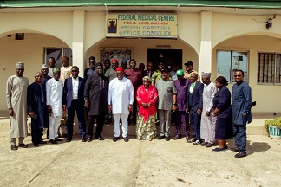  NMA Executive led by the NMA President Dr. Uche R. Ojinmah in a group photograph with the top Management of FMC Taraba, led by the CMD Dr. Aisha Shehu Adamu during NMA visit to her office.  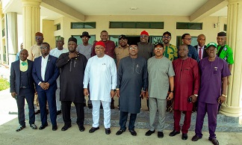  NOC and LOC in a group Photograph with the VC Taraba  State University.  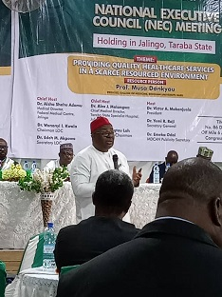  NMA President, Dr. Uche Rowland Ojinmah addressing MDCAN during their NEC Meeting in Jalingo, Taraba State.  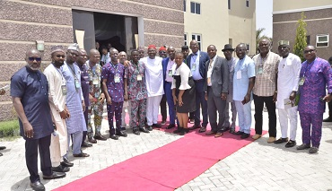  Group photograph at the MDCAN NEC Meeting  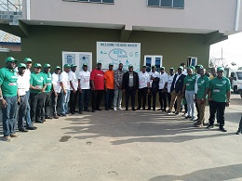  Group Photograph at the NATU Water Factory  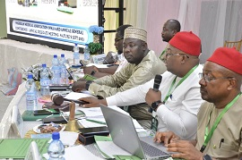  NMA President, Dr. Uche Rowland Ojinmah with other  NOC presiding over the NEC Meeting  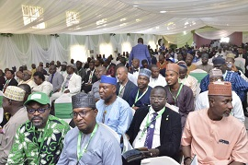  Photograph of the NMA delegate from different State seated during the Opening ceremony of the 63rd AGM/ADM in Jalingo, Taraba State  ANNOUNCEMENT  States are to bid for the hosting of the NMA statutory meetings. Physicians Week 2023, AGC/ADM 2024.  Signed:  Dr. Jide Onyekwelu  SECRETARY GENERAL

