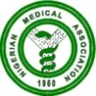 NIGERIAN MEDICAL ASSOCIATION 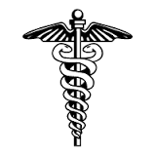
SECRETARIAT REPORT FOR THE MONTH OF AUGUST, 2023
HIGHLIGHTS
The Secretariat activities for the month of August, 2023 are highlighted as follows:
WEEK 1  - Dr. Adetunji Olusesan Adenekan, 2nd Vice President, Nigerian Medical Association represented the NMA President as the Chief Host at the opening ceremony of the 56th Annual General Meeting /Scientific Conference of the Nigerian Dental Association, held on 10th of August, 2023, at Dovers Hotel, Lagos State.  WEEK 2  - NMA President Dr. Uche Rowland Ojinmah attended an interactive meeting with the NMA Cross-River State, and H E, the governor of Cross River State, in Calabar, Cross-River State.  - Dr. Philips Uche Ekpe, immediate past Secretary General represented the NMA President, Dr. Uche Rowland Ojinmah in a meeting for the consideration of the report of the Steering Committee on the proposed establishment of the Professional Assessment Academy of Nigeria (PAAN). This was held on the 14th August, 2023 at JAMB Headquarters Bwari, Abuja.  - Dr. George Nwachi represented the NMA at the Validation Meeting of Nigeria’s regulatory audit report for the priority sector under the African Continental Free Trade Area Agreement (AfCFTA). This was held on 15th August, 2023 at REIZ Continental Hotel, Abuja.  WEEK 3  - Dr. Philips Uche Ekpe represented the NMA President , Dr. Uche Rowland Ojinmah at the launching of the Nigeria best Practice Paper (BPP) on Post Abortion Care. This was held on Monday 21st August, 2023 at the Silver Green Luxury Hotel, Abuja.  WEEK 4  - National Executive Council (NEC) Meeting of the Nigerian Medical Association NMA was held from Sunday 27th August, 2023 to Sunday 3rd September, 2023.  - Below are parts of the events that took place during the NEC meeting  - Sunday 27th August, 2023 was the arrival of the National Officers’ Committee (NOC), and the Secretariat Staff to Owerri, Imo State and a welcome Cocktail for the National Officers.  - Monday 28th August, 2023 was the Flag off of Medical Outreach/Courtesy Visits.  - Tuesday 29th August, 2023 was also a continuation of Medical Outreach/ Courtesy Visits  - Wednesday 30th August, 2023 was the arrival of all the NEC Members to Owerri, Imo State.  - Thursday the 31st of August, 2023 was the CME/ Opening Ceremony of the NEC meeting.  REQUESTS  - Visit our website, www.nationalnma.org for the latest information and upcoming events of the Association.  - Send pictures of activities of your State/FCT Branches and NMA Affiliate Groups to: drjideonyekwelu@yahoo.com and mekutivity2002@yahoo.co.uk  State executives are to send in the full names, office Address, State Secretariat Address, Email Address of the Chairman and Secretary to drjideonyekwelu@yahoo.com and copy mekutivity2002@yahoo.co.uk  This is to update our record.  ANNOUNCEMENT  December 2023 NEC meeting will hold in FCT, Abuja from Sunday 10th December to Sunday 17th December, 2023 at WACS, Conference Centre, Guduwa, Abuja  States Chairmen, Committee Chairmen and Affiliate Bodies should send in their reports for December, 2023 NEC to  drjideonyekwelu@yahoo.com  mekutivity2002@yahoo.co.uk  States are to send a list of Medical Doctors in their States that were elected in the just concluded elections to the NMA National Secretariat.  Signed:  Dr. Jide Onyekwelu  SECRETARY GENERAL  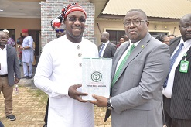  NMA President Dr. Uche Rowland Ojinmah making a presentation to the Hon. Commissioner for Health Imo State, Dr Prosper Success Ohayagha  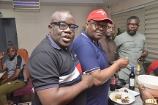  NMA President, Dr. Uche Rowland Ojinmah with Dr. Ofem Egbe Enang, Chairman NMA Committee on Advocacy, Monitoring & Evaluation during the NOC Welcome Cocktail at NEC Meeting in Owerri. | 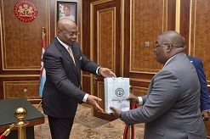  NMA President, Dr. Uche R. Ojinmah making presentation to the executive Governor of Imo State, His Excellency, Sen. Hope Uzodinma.  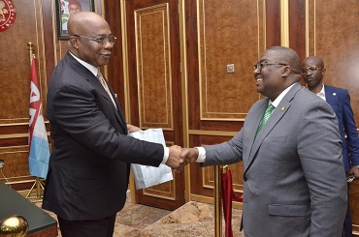  NMA President, Dr. Uche Rowland Ojinmah, having a hand shake with His Excellency, Sen. Hope Uzodinma, the Executive Governor of Imo State.  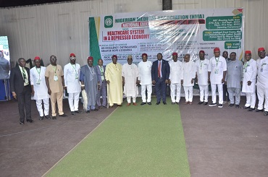  Group photograph of dignitaries with His Excellency, the Governor of Imo state the NMA President and Other NOC after closing of the NEC opening ceremony.  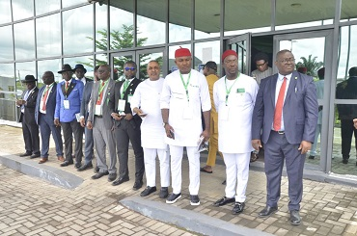  NMA President, Dr. Uche Rowland Ojinmah and delegation waiting to receive the Executive Governor of Imo State to the opening ceremony of NMA NEC meeting  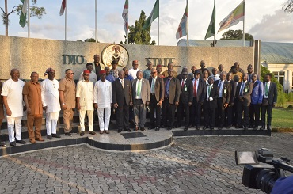  NMA President and the delegation in a group photograph during a courtesy visit to His Excellency, Sen. Hope Uzodinma at Government House Owerri, Imo State.  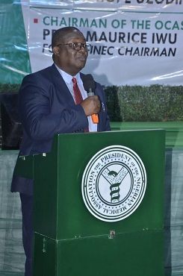  NMA President, Dr. Uche Rowland Ojinmah making his presentation during the opening ceremony of the NMA August NEC Meeting in Owerri, Imo State.  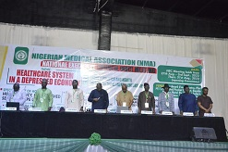NMA NEC II opening prayers  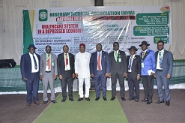NMA NOC in a group photograph with the Executive Governor of Imo State, His Excellency, Sen. Hope Uzodinma  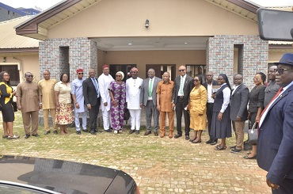  Group Photograph of NMA delegation that visited the CMD of IMSUTH during the NMA NEC at Owerri.  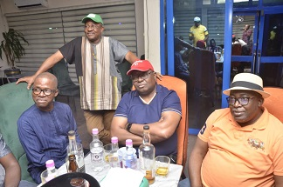  NOC welcome Cocktail during the NEC meeting in Owerri, Imo State.  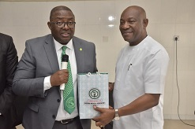  NMA President Dr. Uche R. Ojinmah making presentation to the CMD of Imo State University Teaching Hospital (IMSUTH), Dr Ifeanyi Nwamba  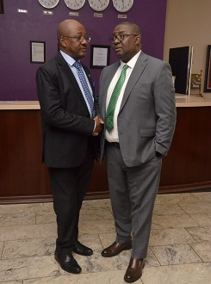  NMA President, Dr. Uche Rowland Ojinmah and the Secretary General Dr. Jide Onyekwelu exchanging pleasantries.

